SUBJECT: Derating Curve for 34044-1
author: larry lim
TECHNICIAN: larry lim
REPORT NO: ENG-14-SEPT-2020-1
date: 09/14/2020

- Part Description:
34044-1 Rev C PCB Assembly
SW: 010E

- Equipment List:
High current test fixture. 80TK Thermocouple Module, Multimeter, Fluke 61 IR Thermometer, Espec Test Chamber

- Test Setup:

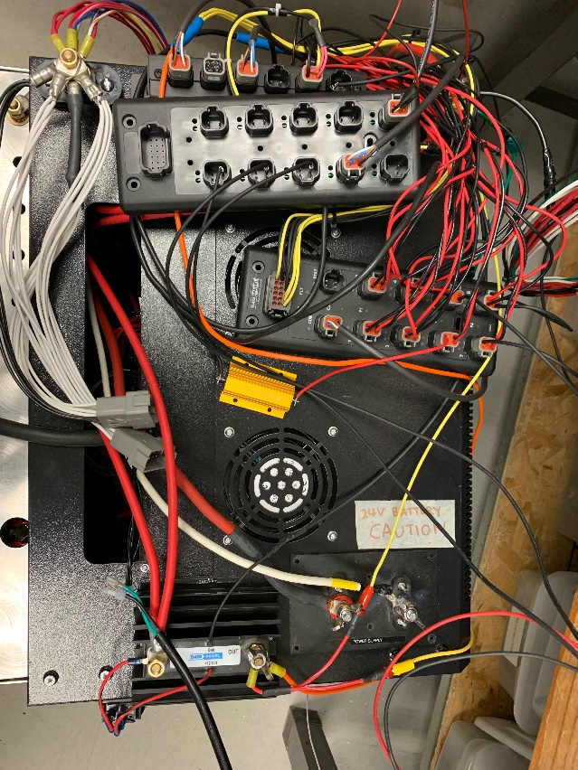 | Unit is first run at ambient. Total temperature increased is subtracted from 80°C to be used as a starting point for derating curve.  Next point on curve would be to start with a minimum load and slowly increase the load until temperature reaches 80°C  All PWM outputs are loaded with 3A.

- Results:

Ambient: 23.6°C
Load Current: 33A
Highest Temperature Recorded: 44 °C
Total Temperature Increase: 20.4°C

59.6°C starting point for derating curve.

Set temperature: 73°C
Load Current: 26A
Highest Temperature Recorded: 79.2°C
Total Temperature Increase: 6.2°C

- Reference Data:

